# DOCS - check for changes in the file and copy to S3 and Git

Overview:

This script will take one arguments:

* a file containing the SQL commands;

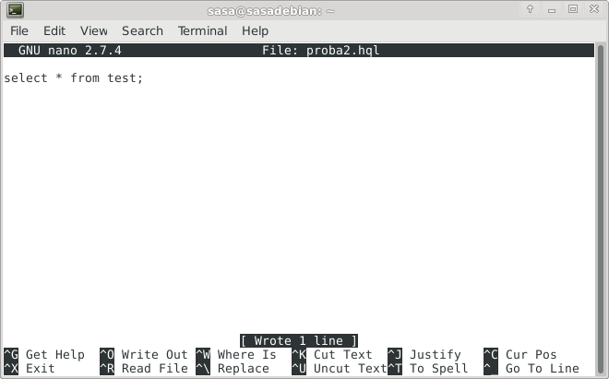

Input files:

* all files from the given S3 bucket;

Output:

* all results - query output SQL files.

### Requirements

### 

* OS: Windows/Linux;
* Terminal;
* software required: Google Chrome (or any web browser) AWS console, Git, Apache Hive;
* Before starting the script, it is necessary to first create local folders /TMP/INPUT and /TMP/OUTPUT/ and run the script from the directory /TMP/INPUT/.

### Script explained

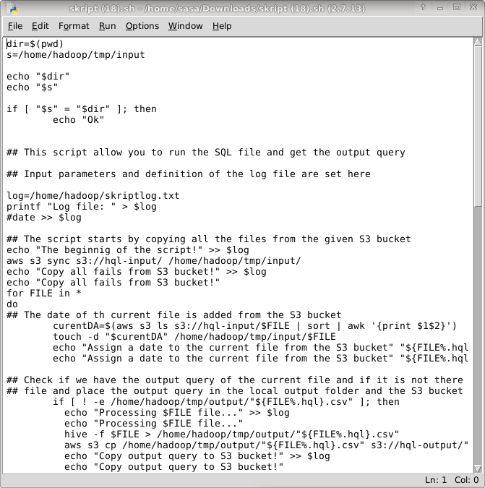

Part 1. - By running the script, the required file and its creation date are loaded from S3 bucket HQL-INPUT and stored in a local directory /TMP/INPUT.

Part 2. - The result of the SQL file, obtained by the *hive* application is copied to the local directory /TMP/OUTPUT and to the S3 bucket - HQL-OUTPUT.

Part 3. - The program enters the infinite loop and checks the date of the stored files an the new one on the S3 bouquet and if there are changes, repeats the operations from Part 1.